Project Title: Rheumatoid Arthritis detection using machine learning

A Project Report
submitted in partial fulfilment of the requirements for the award of the degree of

BACHELOR OF TECHNOLOGY
in

Computer Science and Engineering

Submitted by

Ananya Pradhan
(Roll No: 25scs1003000489)

Under the supervision of

Mr. Shobhit Aggarwal

Assistant Professor



IILM University, Greater Noida, Uttar Pradesh
(November 2025)

Rheumatoid arthritis (RA) is a chronic autoimmune disease characterized by joint inflammation and tissue damage, and early diagnosis is critical to effective treatment. Traditional diagnostic methods rely on clinical evaluation, laboratory biomarkers, and imaging, but can be imprecise or delayed. This project proposes a machine-learning approach using a Random Forest classifier to detect RA from a combination of patient clinical features and laboratory data. The goal is to build a diagnostic aid that supports healthcare providers in identifying RA more reliably and at an earlier stage, while ensuring transparency in the decision-making process.

Abstract
- Introduction
  - Overview
  - Objectives
  - Problem Statement.
- Literature Review
- Methodology and Implementation
- Results and Discussion
- Conclusion and Future Scope
  - Conclusion
  - Future Scope
References

Overview
- Rheumatoid arthritis (RA) is a chronic autoimmune disease that causes inflammation of joints, leading to pain, stiffness, and potential joint damage.
- Early detection of RA is critical because timely treatment can help prevent irreversible joint damage and improve long-term outcomes
- Traditional diagnostic methods rely on clinical evaluation, lab tests (e.g., rheumatoid factor, anti-CCP antibodies) , imaging (like X-rays), and physician expertise. These methods can be time-consuming, sometimes subjective, and may not detect early disease.
- Machine learning offers a powerful tool to analyze large, multidimensional datasets — including electronic health records (EHR), lab data, imaging, and even genomics — to find patterns that might indicate RA much earlier or more accurately than traditional methods.
- However, there are challenges: model interpretability, generalizability, overfitting, data quality, and clinical integration remain major obstacles.

1.2 Objectives

Develop a machine learning model that can classify patients as having RA (vs not) using clinical data, lab results, and/or imaging.

Improve early detection of RA, ideally before pronounced symptoms or radiographic damage.

Problem Statement

Rheumatoid arthritis is a progressive autoimmune disease that is difficult to diagnose early using conventional clinical, lab, and imaging methods.

- There is growing interest in applying machine learning (ML) and artificial intelligence (AI) to RA for various tasks: diagnosis, prognosis, treatment response, and radiographic scoring.
- A bibliometric study of AI in rheumatic diseases showed increasing research trends, especially in RA, with hotspots around early diagnosis, management, and personalized medicine.
- However, despite progress, there are significant challenges: small datasets, lack of standardization, interpretability, and clinical translation.

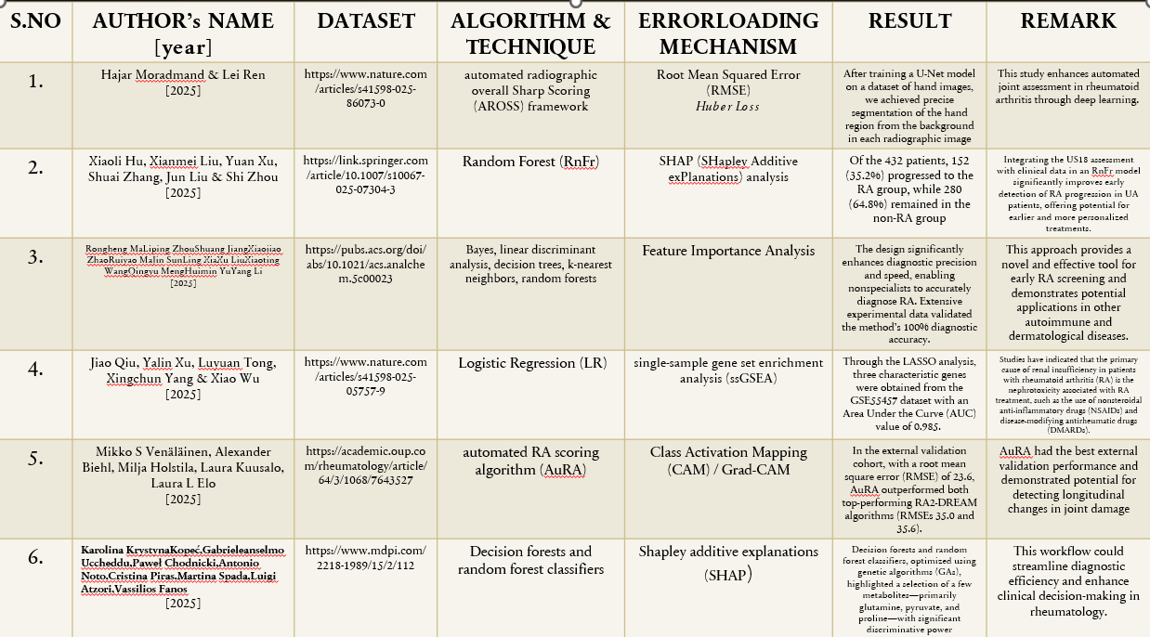
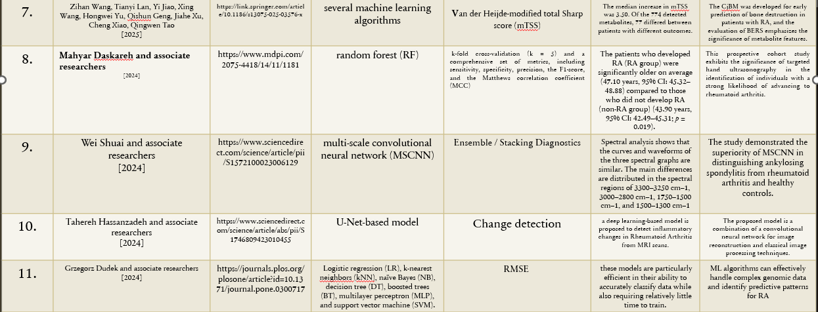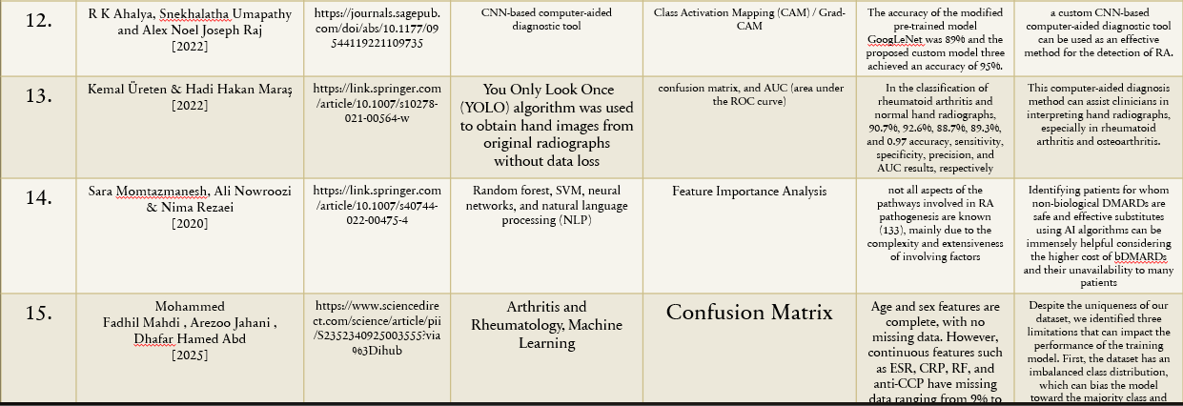

METHODOLOGY:
1. Problem Definition
Problem: Rheumatoid arthritis (RA) is an autoimmune disease that is often diagnosed late or with uncertainty because of reliance on clinical judgment, lab tests, and imaging. Misdiagnosis or delays can lead to irreversible joint damage.
Goal: Develop a machine-learning model, specifically a Random Forest classifier, to detect RA using multimodal patient data (clinical features, labs, imaging, etc.), with high sensitivity and specificity. The model should also be interpretable so clinicians can trust and act on its predictions.
2. Data Collection & Preprocessing
Data Collection: a dataset of patients (RA and controls) with their clinical, lab, and imaging data is gathered.
Data Cleaning
Handling missing values: impute missing clinical/lab data using Random Forest imputation
3.Model Building
- Model Choice: Use Random Forest as the primary classifier
4.Building the pipeline
- A pipeline chains together preprocessing steps + model training into a single object.
- It helps avoid data leakage: transformations learned on the training set are automatically applied to new/unseen data.
5. Evaluating on test data
- Predict class labels
- Predict class probabilities and Compute Classification Metrics
6.Save the trained model

IMPLEMENTATION:

https://colab.research.google.com/drive/1zRXBTi6iRdKW7RbzUmI9gyNWh0KNPQtb?usp=sharing

Test Accuracy: 0.7333333333333333
Confusion Matrix:
[[416 2]
[150 2]]
Classification Report:
precision recall f1-score support

Negative 0.73 1.00 0.85 418
Positive 0.50 0.01 0.03 152

accuracy 0.73 570
macro avg 0.62 0.50 0.44 570
weighted avg 0.67 0.73 0.63 570

- Measuring disease activity is crucial in choosing the optimal treatment plan, determining response to therapy, and prognosis. Moreover, predicting disease severity early on could assist in timely administration of the most suitable medications.
- The model’s false positives suggest a risk of over-diagnosing RA in patients with borderline abnormalities — this could lead to unnecessary referrals or anxiety. In a clinical deployment, one might mitigate this by using a higher decision threshold or combining model predictions with clinician judgment.

5.1Conclusion
This study shows that ML tools could help doctors find rheumatoid arthritis faster and more accurately. But to really use it in hospitals, we need to test the model on data from other clinics (external validation) and make sure its probability estimates are well-calibrated — meaning the model’s predicted risk matches the real risk.

5.2Future Scope
    - Include joint images (X-rays, ultrasound) so the model can understand damage to joints better.
    - Use AI to forecast how patients will respond to treatments (like methotrexate or biologics) using their medical history.
    - Develop AI tools that automatically score joint damage (e.g., Sharp score) from X-ray images — this saves time and reduces human error.
.

- scholar.google.com
- colab.research.google.com
- https://pmc.ncbi.nlm.nih.gov

